Functional & Performance Testing Template
Model Performance Test
Date | 2 October 2026
Team ID | SWTID-2026-9615
Project Name | Streamlining IT Procurement: Automating Standard Laptop Orders with Flow Designer
Maximum Marks | Not specified in source document

Test Scenarios & Results
Test Case ID | Scenario (What to test) | Test Steps (How to test) | Expected Result | Actual Result | Pass/Fail | Screenshot
FT-01 | Flow Creation – Standard Laptop Task | Open ServiceNow → Flow Designer → New → Flow. Set Flow Name to “Standard laptop task”, Application to Global, Run user to System user, then submit. | A Flow named “Standard laptop task” is created with the specified properties. | Source documents the configuration steps; no explicit execution result is stated. | Not specified | 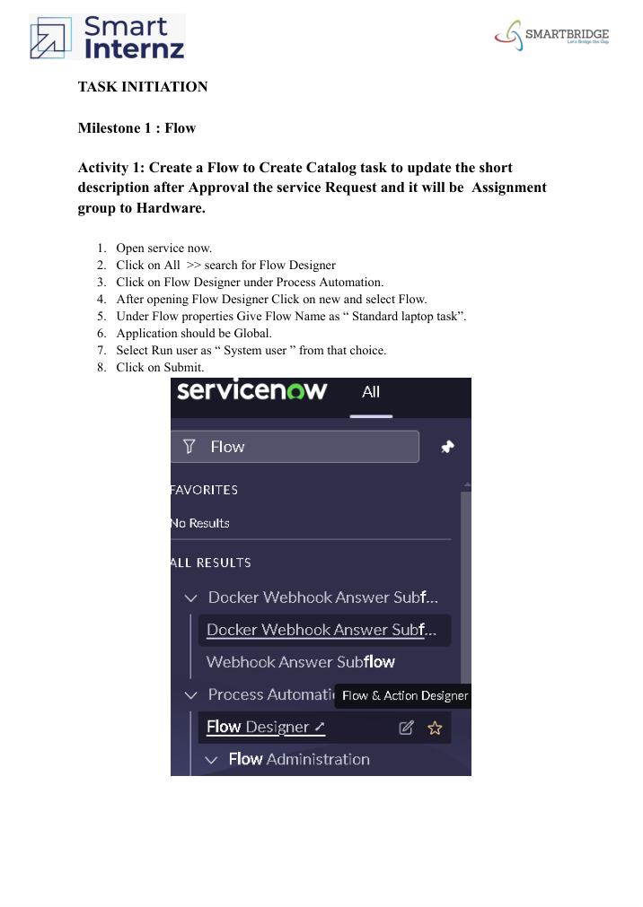
FT-02 | Service Catalog Trigger & Catalog Task Action | Add a Service Catalog trigger. Add “Create Catalog Task” action. Use Requested Item Record; set short description and description to “Laptop need to Configured”, Assignment group to Hardware, and Approval to Approved. Save and activate. | The flow contains the Service Catalog trigger and creates a Catalog Task with the specified values. | Source documents the configuration and activation steps; no explicit pass/fail result is stated. | Not specified | 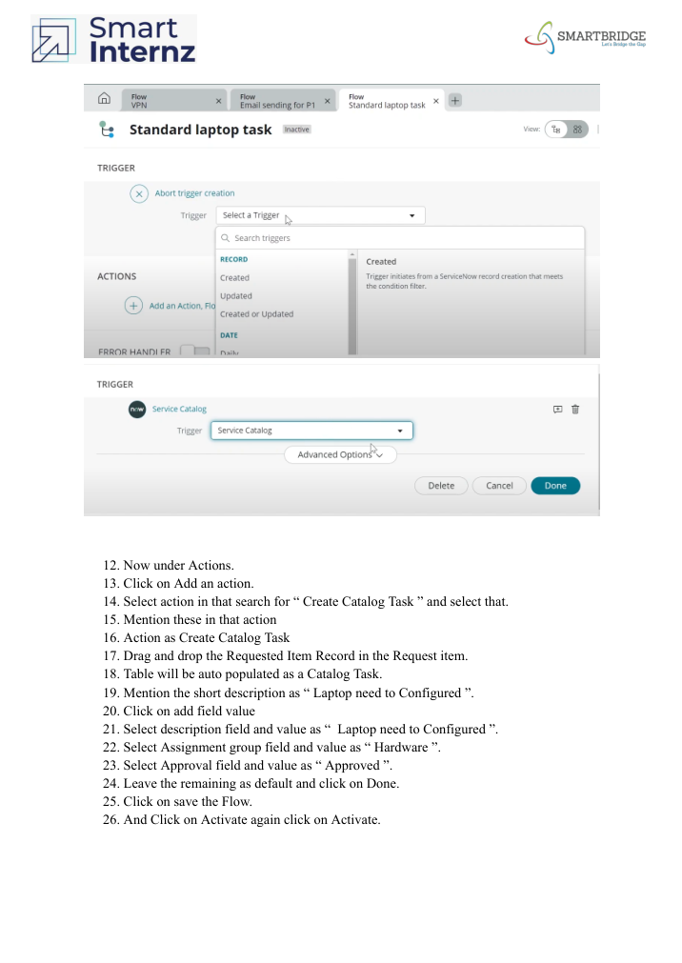
FT-03 | Flow Assignment to Standard Laptop Service Catalog | Open Maintain Items → Standard Laptop → Process engine. Remove remaining automations and add the “Standard Laptop Task” flow. Save. | The Standard Laptop service catalog item uses the created flow. | Source documents the assignment steps; no explicit execution result is stated. | Not specified | 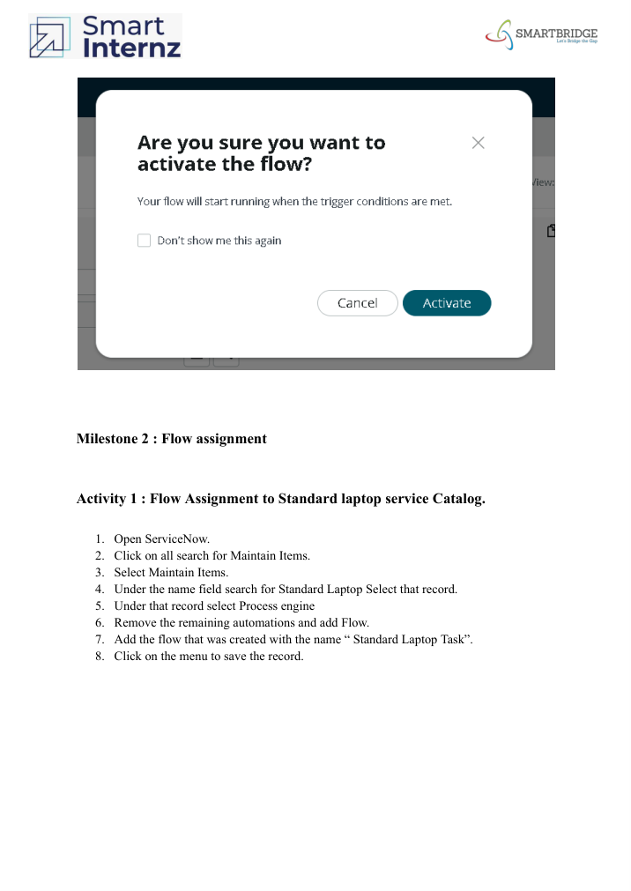
FT-04 | Service Catalog Order & Approval | Open Service Catalog → Hardware → Standard Laptop → Order Now. Open the request number, open Approvers, and approve the request. | The Standard Laptop request is placed and the approval can be performed. | Source documents the ordering and approval procedure; no explicit pass/fail result is stated. | Not specified | 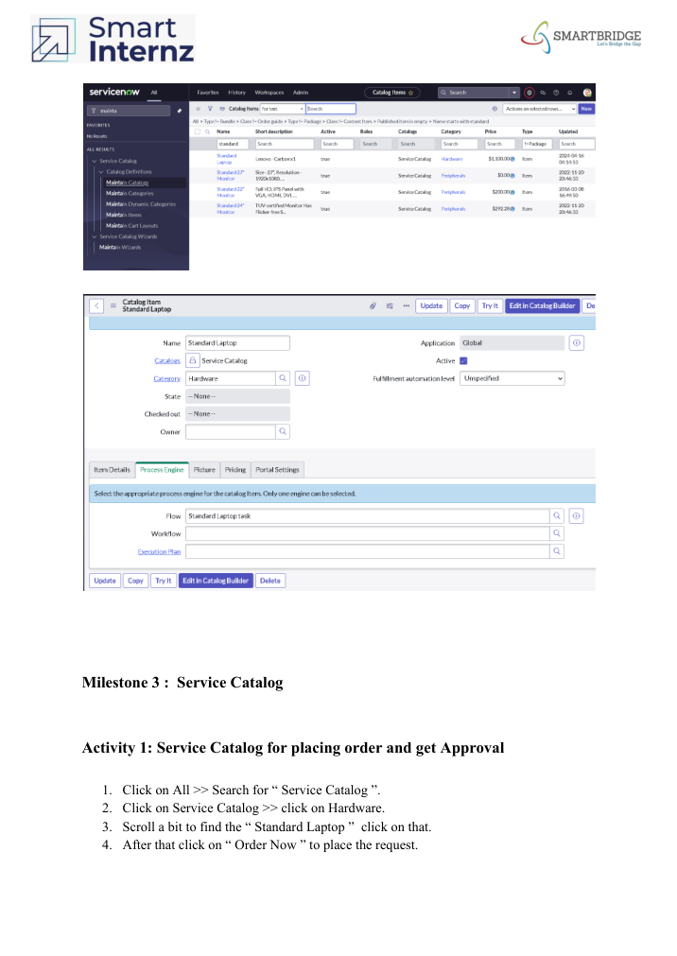
FT-05 | Catalog Task Verification | Open the Requested Item and scroll to Catalog Tasks. Open the task and inspect the short description and assigned group. | Catalog Task shows the updated short description and assigned group. | Source states that the record is opened to see the updated status, short description, and assigned group; no explicit pass/fail result is stated. | Not specified | 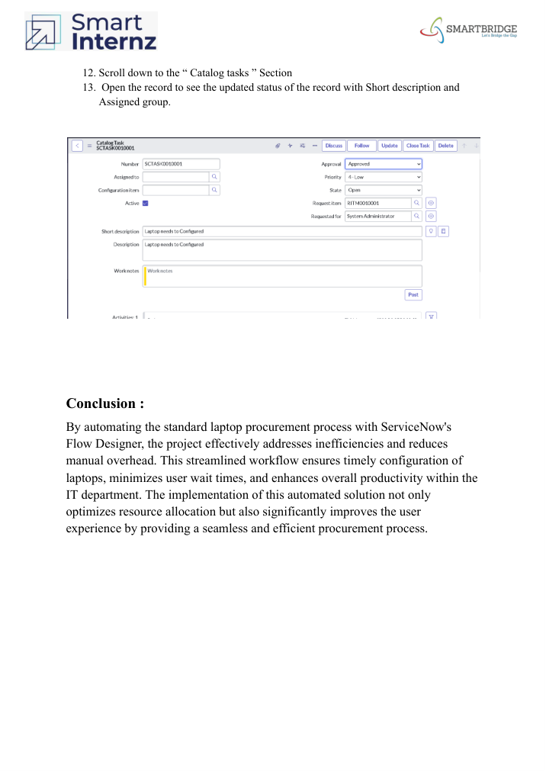
PT-01 | Workflow Efficiency / Manual Overhead | Execute the documented standard laptop ordering workflow and observe whether task creation and assignment are handled by the Flow. | Workflow should automate task generation and assignment, reducing manual intervention. | The source describes this as the project objective/outcome, but provides no measured performance value. | Not specified
PT-02 | Timely Configuration Workflow | Place a Standard Laptop request, complete approval, and verify the resulting Catalog Task assigned to Hardware. | Task should be generated and assigned so configuration can proceed promptly. | No measured timing or performance result is provided in the source. | Not specified
PT-03 | End-to-End Procurement Flow | Run the process from Standard Laptop order through approval and Catalog Task verification. | The workflow should complete without the documented manual procurement delays and should produce the expected Catalog Task. | Source provides the workflow and conclusion but no formal performance measurement or pass/fail result. | Not specified

Source Note: The supplied project document describes workflow implementation and verification steps, but does not provide numerical performance measurements or explicit Pass/Fail outcomes. Those fields are therefore marked as not specified rather than inferred.

